Hello Neighbor! If you or anyone you know is in need of supplemental food, we have begun a distribution in the neighborhood on Saturday mornings. **Free food and no appointment necessary – walk or drive up.** Please share and thanks for helping us spread the word in the area!

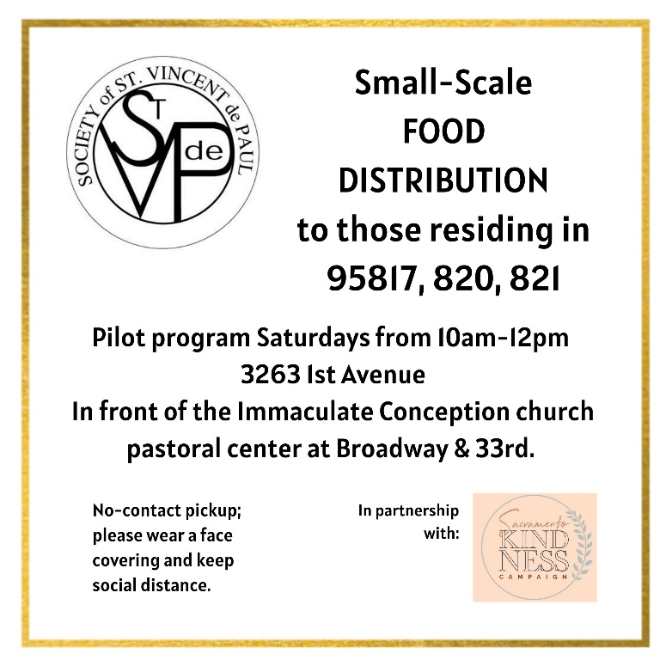

Hello Neighbor! If you or anyone you know is in need of supplemental food, we have begun a distribution in the neighborhood on Saturday mornings. **Free food and no appointment necessary – walk or drive up.** Please share and thanks for helping us spread the word in the area!



Hello Neighbor! If you or anyone you know is in need of supplemental food, we have begun a distribution in the neighborhood on Saturday mornings. **Free food and no appointment necessary – walk or drive up.** Please share and thanks for helping us spread the word in the area!



Hello Neighbor! If you or anyone you know is in need of supplemental food, we have begun a distribution in the neighborhood on Saturday mornings. **Free food and no appointment necessary – walk or drive up.** Please share and thanks for helping us spread the word in the area!

